Preserving the Starry Skies: Light Pollution’s Impact on Cultural Heritage and Ecological Balance in Bears Ears National Monument

### Mustafa Sameen

### Colorado College State of the Rockies Project April 24, 2025

**Abstract**

Bears Ears National Monument (BENM) faces an emerging threat from artificial light pollution that endangers both its cultural and ecological integrity. This study examines how increasing artificial lighting affects Indigenous ceremonies dependent on celestial visibility, disrupts nocturnal wildlife behavior, and impacts local economies. Through interviews with tribal members and land managers, survey data from 300+ respondents, and analysis of BLM visitation records, I documented widespread concern about these impacts. Key findings reveal that 47% of visitors would reduce future visits if night sky quality diminished—potentially costing the region $191,000 annually in tourism revenue under even minor light pollution increases. The research highlights how Traditional Indigenous Knowledge can inform effective management practices, with 80% of community members supporting dark sky preservation measures. By integrating shielded lighting technologies with community-driven initiatives, Bears Ears can balance necessary development with preserving the starry skies vital to cultural practices, wildlife, and sustainable tourism.

**Contents**

1. Introduction 3
2. Research Methodology 3
   1. Mixed-Methods Approach . . . . . . . . . . . . . . . . . . . . . . . . . . . . 3
   2. Data Collection . . . . . . . . . . . . . . . . . . . . . . . . . . . . . . . . . . 3
3. Cultural Impact of Light Pollution 4
   1. Traditional Ceremonies and Night Sky Dependence . . . . . . . . . . . . . . 4
   2. Knowledge Transmission and Modernization Challenges . . . . . . . . . . . . 4
4. Ecological Impact of Light Pollution 5
   1. Wildlife Disruption . . . . . . . . . . . . . . . . . . . . . . . . . . . . . . . . 5
   2. Plant-Pollinator Relationships . . . . . . . . . . . . . . . . . . . . . . . . . . 6
5. Economic Analysis 7
   1. Visitation Trends and Monument Impact . . . . . . . . . . . . . . . . . . . . 7
   2. Economic Value and Projected Losses from Light Pollution . . . . . . . . . . 9
6. Community Perspectives 9
   1. Survey Findings on Light Pollution . . . . . . . . . . . . . . . . . . . . . . . 9
   2. Balancing Development and Preservation 10
7. Policy Recommendations 10
   1. Responsible Lighting Solutions 10
   2. Community-Led Initiatives 11
   3. Implementation Timeline 11
8. Conclusion 11

# Introduction

Bears Ears National Monument represents a landscape of exceptional cultural and ecological significance in southeastern Utah. Designated in 2016 and restored to its original boundaries in 2021, this 1.36 million acre expanse contains thousands of archaeological sites documenting human presence spanning more than 13,000 years. For the Navajo, Hopi, Ute Mountain Ute, Ute, and Zuni peoples, Bears Ears constitutes an ancestral homeland where traditional practices continue to this day.

The monument’s pristine night skies—increasingly rare in the American West—support nocturnal ecological processes and traditional cultural practices. Yet as visitation increases and surrounding communities develop, artificial light threatens to disrupt this resource. Light pollution—defined as excessive or misdirected artificial light—alters natural darkness that has shaped both cultural practices and biological adaptations over millennia (H¨olker et al., 2010).

This research explores four interconnected questions:

1. How does light pollution impact Indigenous cultural practices dependent on celestial visibility?
2. What economic value do dark skies provide to the regional tourism economy?
3. What ecological impacts does artificial lighting have on monument wildlife and ecosys- tems?
4. What policies can effectively balance development needs with dark sky preservation? By integrating scientific data with traditional knowledge, this research provides evidence-

based recommendations for preserving the night skies that remain essential to cultural con- tinuity and ecological health in this sacred landscape.

# Research Methodology

## Mixed-Methods Approach

This study employed a mixed-methods approach integrating qualitative interviews, quan- titative surveys, economic modeling, and comparative analysis. This framework enabled triangulation across multiple data sources while respecting both scientific and Traditional Indigenous Knowledge systems.

## Data Collection

Key data collection methods included:

* + - **Qualitative Interviews:** I conducted 14 in-depth interviews with BLM officials, tribal members, and local residents, including Harold Drake from the Navajo Nation (Drake, 2025), a BLM official from the Monticello Field Office (Bureau of Land Man- agement, 2025), and community members from Monument Valley (Anonymous, 2025a), Hopi (Anonymous, 2025b), and Navajo (Anonymous, 2025c) tribes.
    - **Community Survey:** I distributed a 22-question survey addressing dark sky percep- tions and practices, collecting 300+ responses with a 76% overall response rate.
    - **Visitation Analysis:** I analyzed 11 years (2013-2023) of BLM visitation data to es- tablish patterns before and after monument designation (Bureau of Land Management, 2023).
    - **Economic Modeling:** I adapted methodology from Great Sand Dunes National Park research (Yang et al., 2024) to assess potential economic impacts of light pollution.

My research adhered to ethical protocols for working with Indigenous communities, in- cluding obtaining permissions, respecting knowledge restrictions, and engaging tribal repre- sentatives in data interpretation.

# Cultural Impact of Light Pollution

## Traditional Ceremonies and Night Sky Dependence

For Indigenous peoples of Bears Ears, the night sky constitutes an integral component of spiritual practice and cultural identity. Survey data reveals that 56% of community members participate in nighttime cultural activities dependent on dark skies and celestial visibility.

The Nightway Chant (Yeibichai), a significant Navajo healing ceremony, exemplifies this dependency on celestial markers. As Harold Drake explained, ”The stars are our ceiling, our calendar, our stories... when we cannot see them, we lose our connection to the teachings of our ancestors” (Drake, 2025). This sentiment was echoed by 40% of survey respondents who identified cultural preservation as their primary concern regarding light pollution.

## Knowledge Transmission and Modernization Challenges

The transmission of cultural knowledge between generations depends significantly on clear night skies. Elders utilize stars as mnemonic devices in storytelling, with specific constel- lations serving as anchors for complex oral histories. Artificial light that diminishes stellar visibility directly impedes this knowledge transmission.

Community members expressed nuanced perspectives on balancing necessary develop- ment with dark sky preservation. The ”Light Up Navajo” program, which has brought electricity to previously unserved households on the Navajo Nation, exemplifies this tension (American Public Power Association, 2021). As one Monument Valley resident noted, ”We need electricity, we need progress, but we also need to keep our connection to the stars. Our children deserve both” (Anonymous, 2025a).

Tribal communities near Bears Ears advocate for thoughtful development approaches that respect cultural values while addressing infrastructure needs. This includes support for dark sky-friendly lighting designs, lighting curfews near sacred sites, and zoned approaches that preserve complete darkness in culturally significant areas.

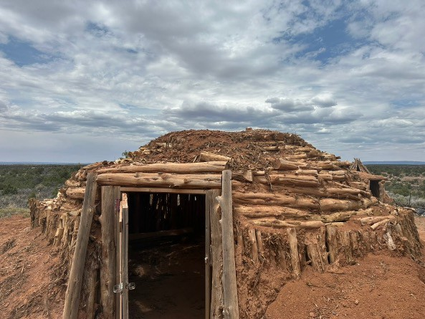

Figure 1: A traditional female hogan near Bears Ears, Blanding, Utah—an enduring symbol of Navajo cultural heritage and spiritual practices. These structures are integral to cere- monies and storytelling, often conducted under natural night skies.

# Ecological Impact of Light Pollution

## Wildlife Disruption

Light pollution significantly affects wildlife behavior and population dynamics at Bears Ears. Survey results revealed that 72% of respondents expressed concern about impacts on noc- turnal wildlife, making this the second highest concern after cultural preservation (Figure 2).

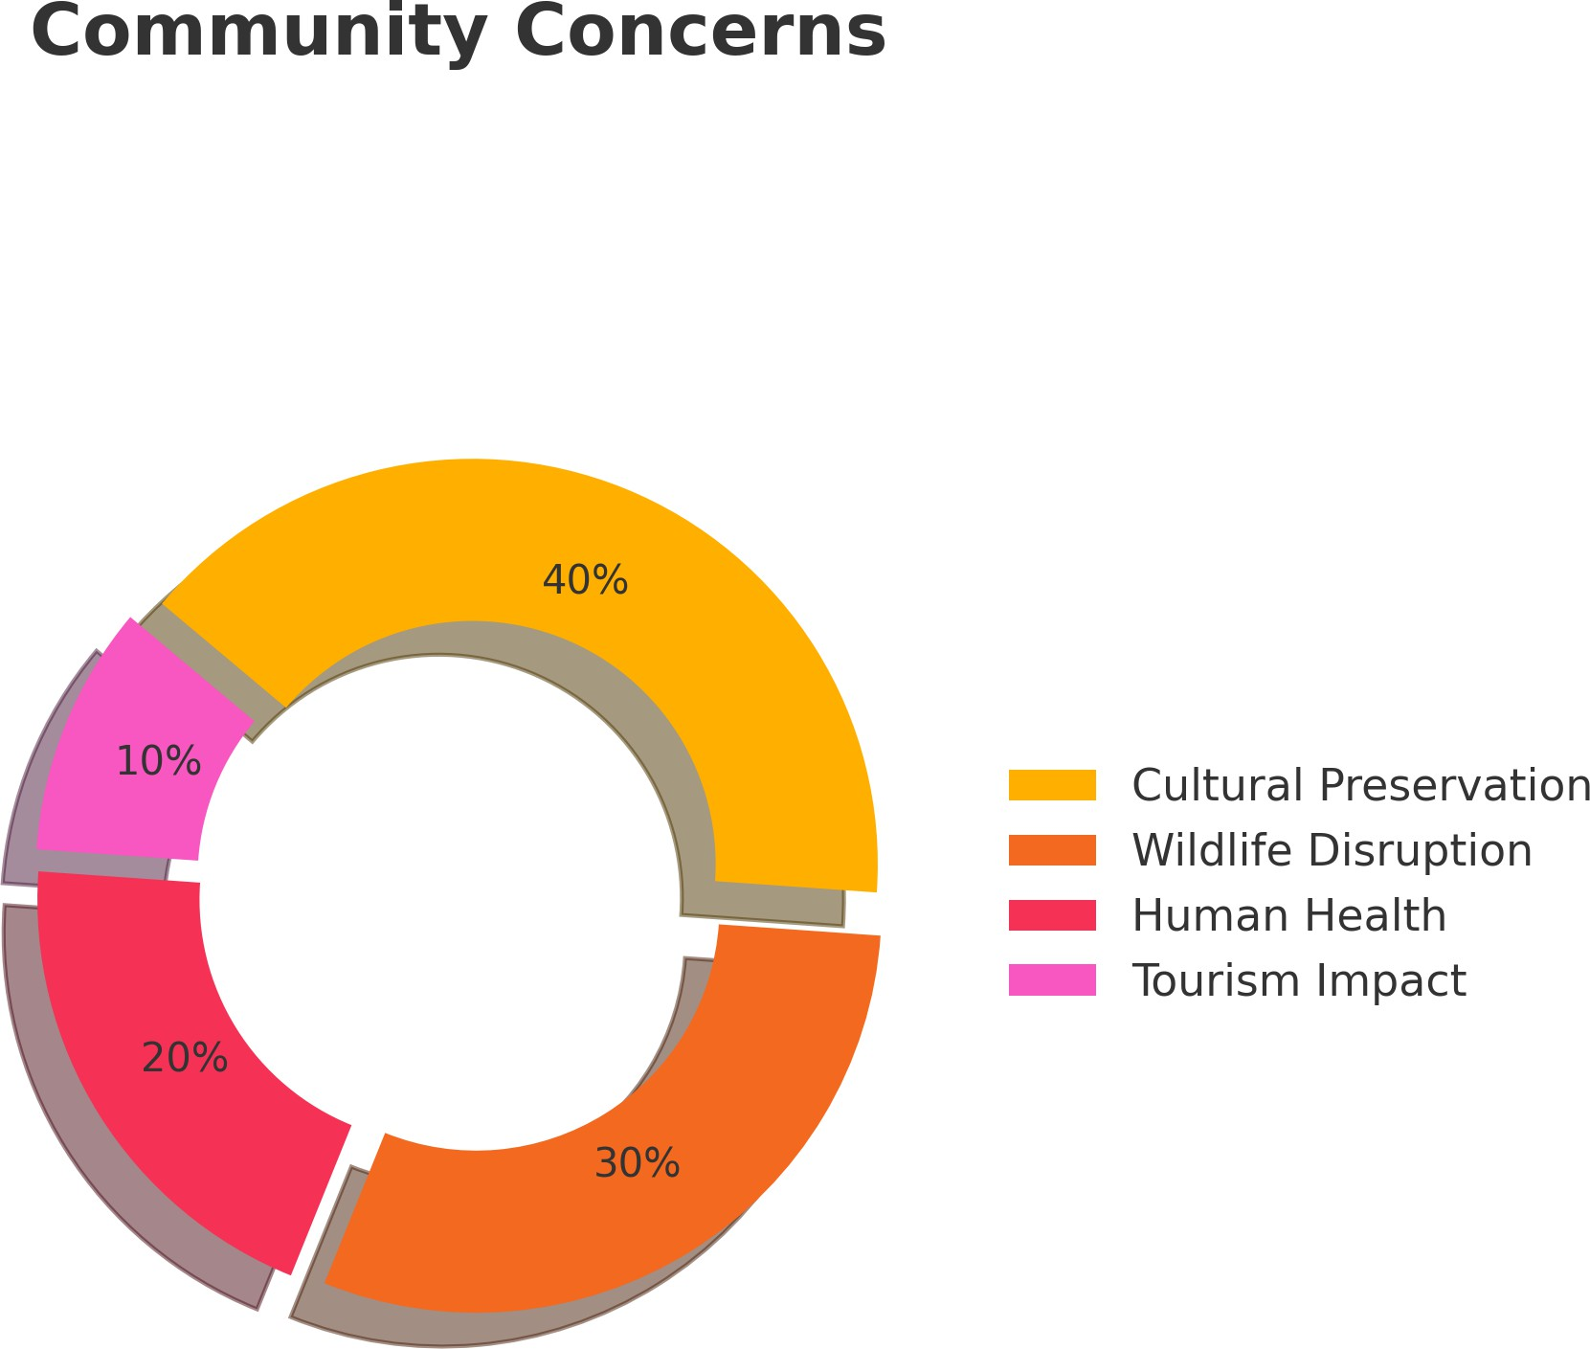

Figure 2: Survey respondents highlighted cultural preservation (40%) as their most signifi- cant concern regarding light pollution, followed by wildlife disruption (30%), human health impacts (20%), and economic effects on tourism (10%).

Nocturnal mammals—including multiple bat species, foxes, and rodents—show altered behavior patterns in response to artificial lighting. For migratory birds utilizing the Pacific Flyway, light pollution causes disorientation during migration, collision risks with structures, and disrupted feeding patterns (Longcore and Rich, 2004).

Tourism-related activities (50%), urban/traffic lighting (32%), and residential lighting (27%) were identified as the primary pollution sources. Temporary camping lights and vehicle headlights were cited as particularly disruptive due to their unpredictable nature.

## Plant-Pollinator Relationships

Light pollution significantly disrupts plant-pollinator relationships that have evolved over millennia. Insect pollinators, particularly moths active during crepuscular and nocturnal hours, experience disorientation, reduced efficiency, and population declines in light-sensitive species (Ho¨lker et al., 2010).

The Rocky Mountain Agapema moth (*Agapema homogena*) serves as an indicator species for light pollution impacts. Found in high-altitude forests throughout the monument, this moth plays a critical ecological role as a native plant pollinator (Figure 3).



Figure 3: Rocky Mountain Agapema – Found in high-altitude forests across the Southwest

U.S. and Mexico. Though globally secure, artificial lighting disrupts its nocturnal behavior, contributing to local population declines.

The decline of this and other pollinators affects plant reproduction throughout Bears Ears, with consequences for forest regeneration and understory plant communities. Light pollution creates concentric zones of ecological disruption extending far beyond immediate light sources, with effects extending up to 10 kilometers along canyons and valleys.

# Economic Analysis

## Visitation Trends and Monument Impact

Bureau of Land Management data reveals significant growth in visitation at Bears Ears over the past decade (Figure 4). Total annual visitors increased from 245,096 in 2013 to 493,543 in 2023, representing 101% growth (Bureau of Land Management, 2023).

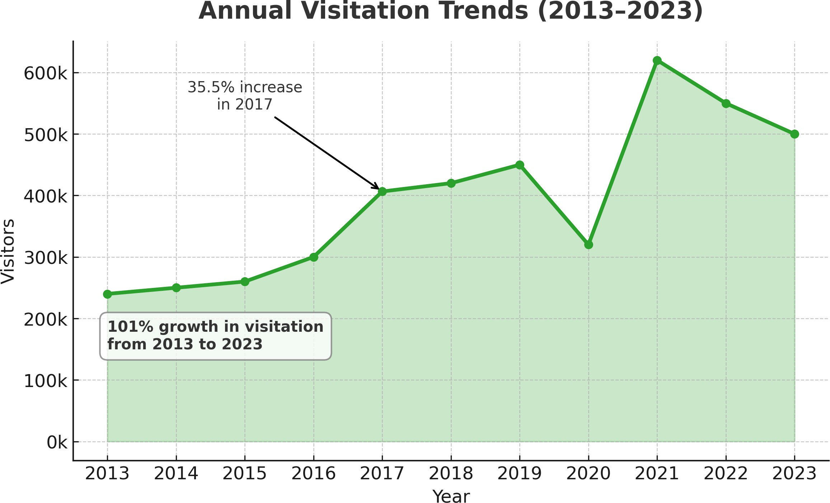

Figure 4: Bears Ears National Monument annual visitation (2013-2023), showing significant growth over the decade with notable increases following monument designation in 2016 and post-COVID recovery in 2021.

Monument designation in December 2016 corresponded with a 35.5% visitor increase in 2017. Comparing pre-designation (2013-2016) and post-designation (2017-2023) periods reveals a 75% increase in average annual visitation (Figure 5).

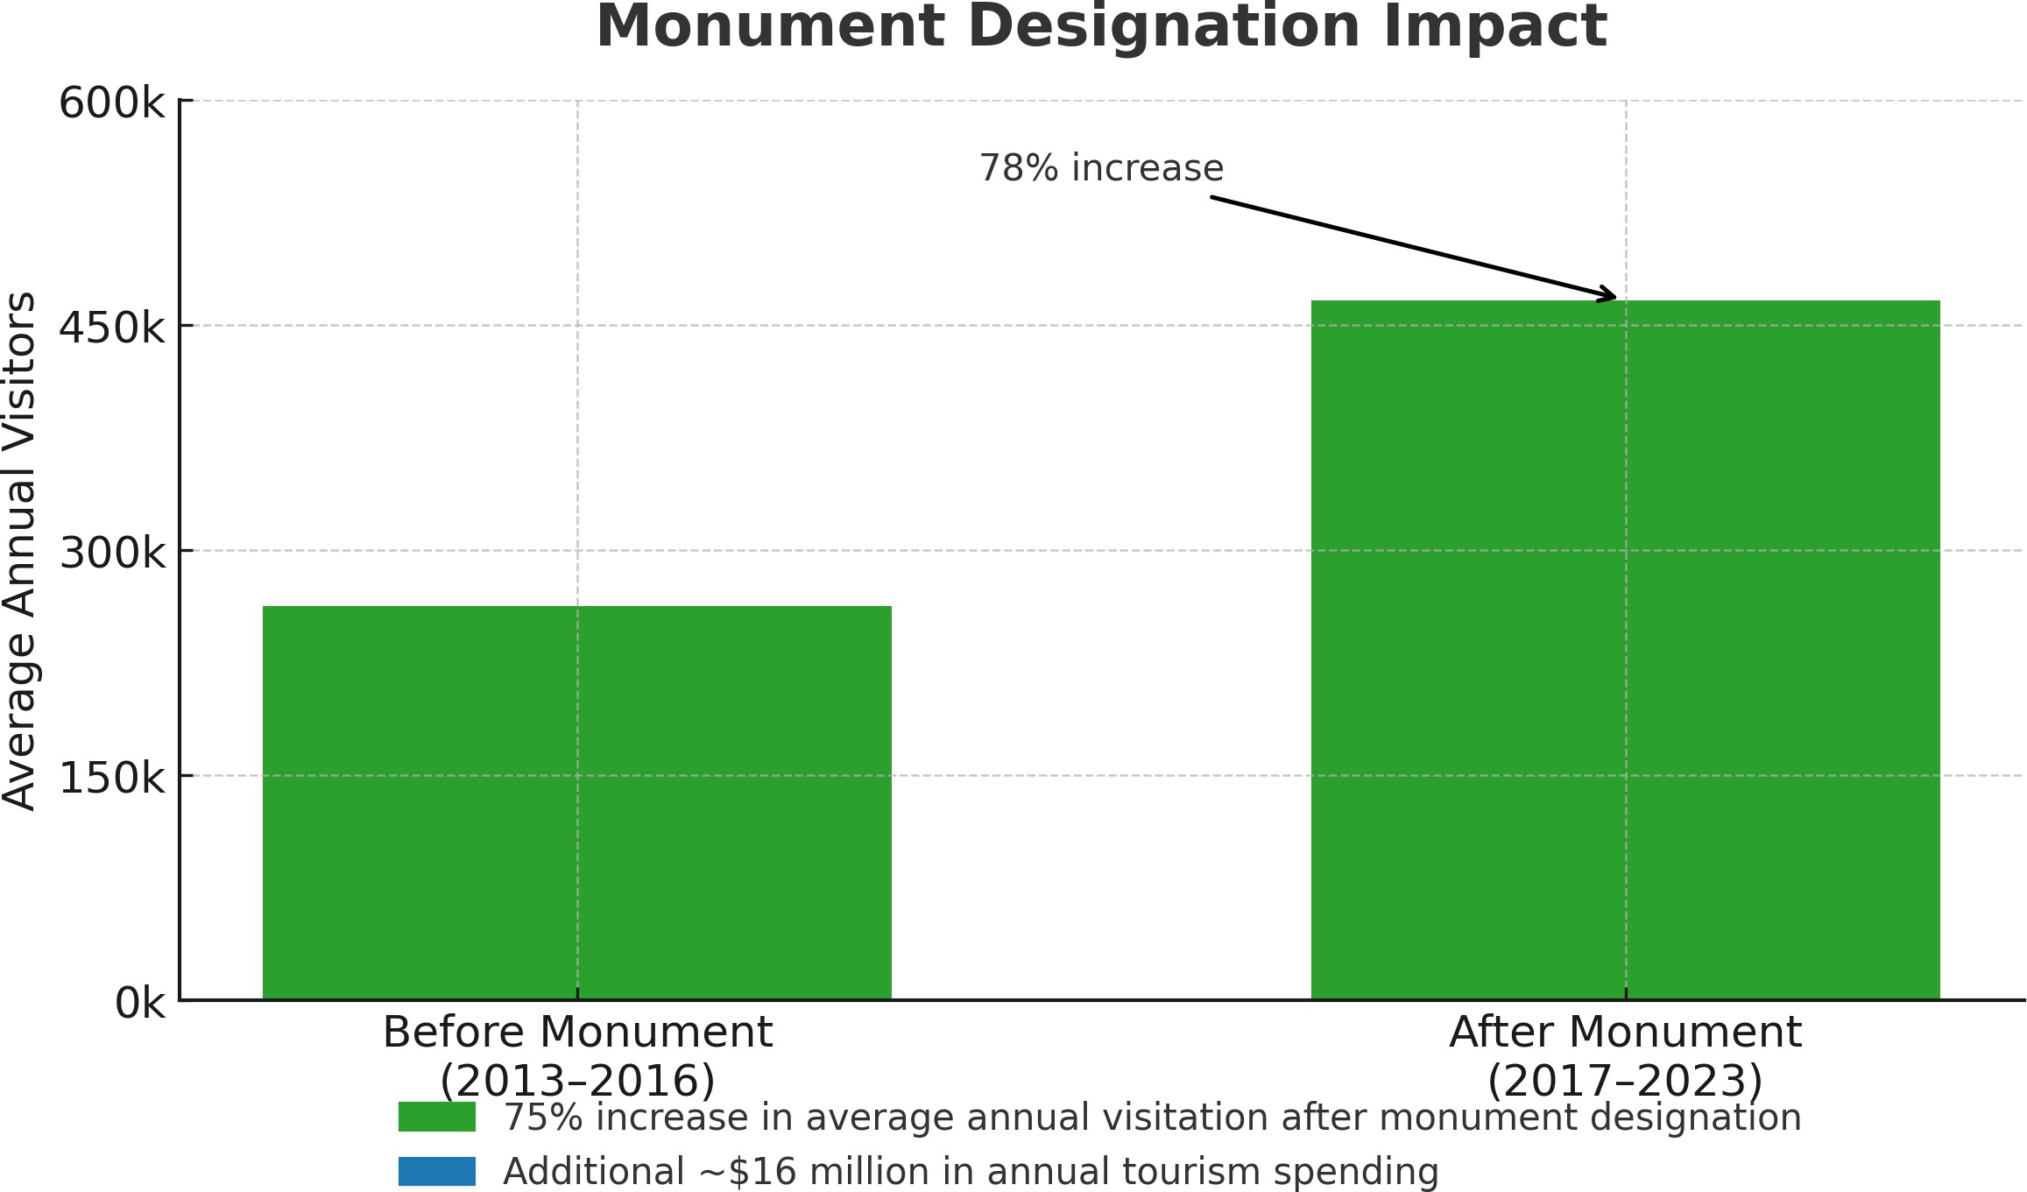

Figure 5: Comparison of average annual visitation before monument designation (266,445 visitors, 2013-2016) and after designation (466,107 visitors, 2017-2023), showing a 75% in- crease.

This increased visitation translates to approximately $16 million in additional annual tourism spending, with dark skies representing a significant component of this economic activity.

## Economic Value and Projected Losses from Light Pollution

Bears Ears’ pristine night skies generate substantial economic value. This can be measured through direct tourism spending (approximately $39.5 million annually) and visitor benefits valued at 4-15x direct spending. Survey responses revealed that visitors with astronomical interests stay 2.3 times longer than typical visitors.

Most significantly, 47% of visitors indicated they would reduce future visitation if night sky quality diminished, matching findings from research at Great Sand Dunes National Park (Yang et al., 2024). Based on contingent behavior methodology applied to Bears Ears’ current visitation levels, I projected:

* + - Under minor light pollution increases (equivalent to Alamosa, Colorado):
      * Direct tourism revenue loss: $191,000 annually
      * Total economic impact (with 1.10 multiplier): $210,100 annually
      * Net visitor benefits loss: $2.9 million annually
      * Equivalent to 9,870 fewer visitor-days per year
    - Under moderate light pollution increases:
      * Direct tourism revenue loss: $300,000 annually
      * Total economic impact: $330,000 annually
      * Net visitor benefits loss: $4.5 million annually

These projections demonstrate that even subtle degradation of night sky quality would have substantial economic consequences for the region.

# Community Perspectives

## Survey Findings on Light Pollution

Survey responses from community members, visitors, and stakeholders revealed strong con- sensus regarding the importance of dark sky preservation. Analysis of 300+ completed surveys provided quantitative insights into community priorities.

Key findings included:

* + - 83% of respondents support dark sky preservation policies (52% strongly support, 31% support)
    - Cultural preservation emerged as the primary concern (40% of respondents)
    - Wildlife disruption ranked second (30% of respondents)
    - Tourism-related activities (50%), urban/traffic lighting (32%), and residential lighting (27%) were identified as primary pollution sources

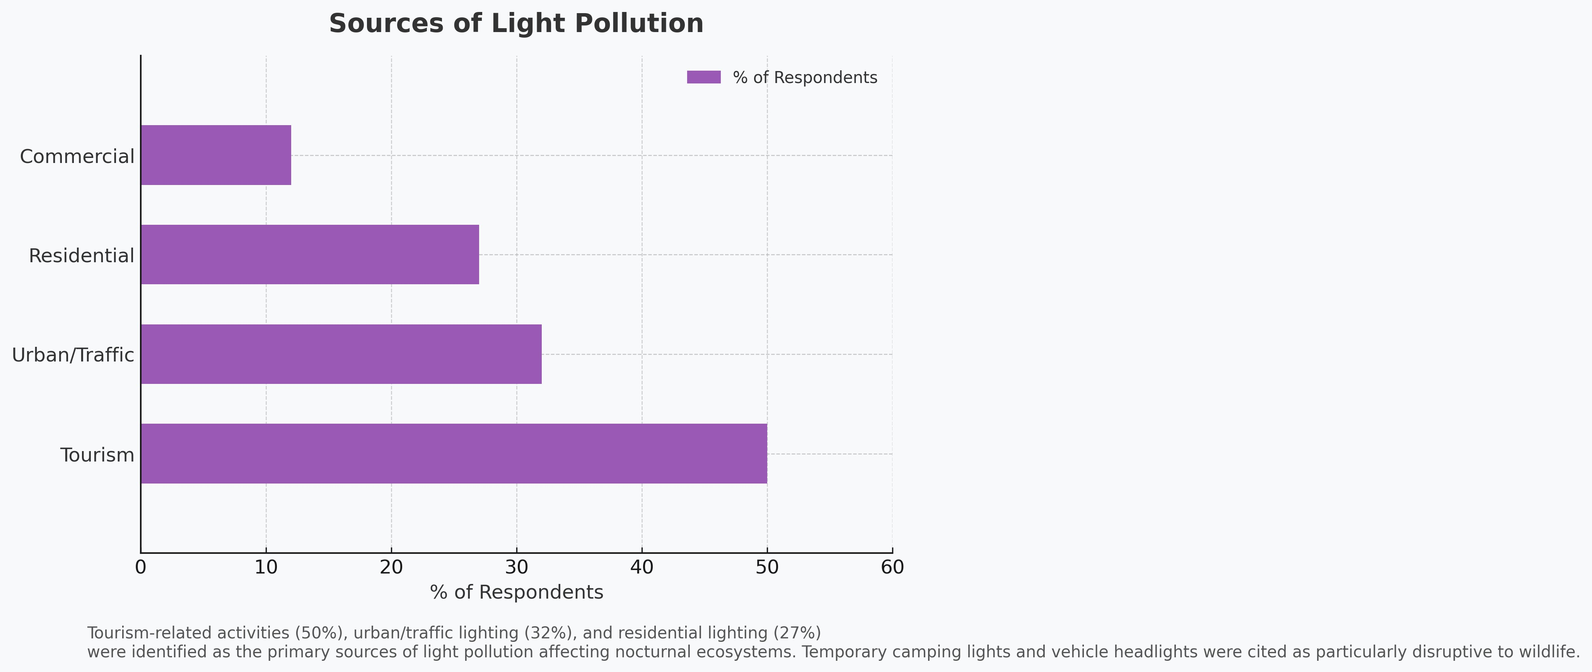

Figure 6: Primary sources of light pollution identified by survey respondents, with tourism- related activities (50%), urban/traffic lighting (32%), and residential lighting (27%) emerging as the most significant contributors.

Support for dark sky preservation crossed demographic boundaries, with majorities of both tribal and non-tribal respondents favoring stronger protection measures. This shared value provides common ground for collaborative approaches among diverse stakeholders.

## Balancing Development and Preservation

A BLM official noted during interviews that ”community advocacy influences future land management decisions” (Bureau of Land Management, 2025). This recognition of community input suggests that balanced approaches integrating development needs with preservation goals are likely to receive institutional support.

My research findings indicate that dark sky preservation efforts at Bears Ears will be most successful when they acknowledge legitimate development needs while providing practical alternatives to high-impact lighting practices. Community perspectives favor this balanced approach rather than more restrictive preservation strategies.

# Policy Recommendations

Based on my research findings and stakeholder input, I propose a framework for preserv- ing dark skies at Bears Ears that balances development needs with cultural and ecological preservation.

## Responsible Lighting Solutions

Technical solutions represent the most direct approach to reducing light pollution while maintaining necessary functionality:

* + - Install shielded, downward-facing lights at developed sites to prevent upward light scatter
    - Use amber/warm LED lighting (3000K color temperature) to reduce blue light emis- sions that cause disproportionate skyglow (Gaston et al., 2012)
    - Implement motion-activated lighting where continuous illumination is unnecessary
    - Establish lighting curfews near cultural sites and sensitive habitats
    - Create lighting zones with varying protection levels based on cultural significance and ecological sensitivity

## Community-Led Initiatives

Successful preservation requires community engagement and leadership:

* + - Support tribal-led lighting policies that integrate Traditional Indigenous Knowledge
    - Create advisory boards with representatives from all stakeholder groups
    - Pursue International Dark Sky Sanctuary designation (International Dark-Sky Asso- ciation, 2020)
    - Develop collaborative education programs with surrounding communities
    - Partner with utility companies on modernizing infrastructure to reduce light pollution

## Implementation Timeline

A phased approach recognizes resource constraints while prioritizing high-impact actions:

* + - **Immediate (0-1 Year):** Establish baseline measurements, form advisory group, de- velop interpretive materials
    - **Short-Term (1-3 Years):** Retrofit existing lighting, launch education programs, initiate Dark Sky designation application
    - **Medium-Term (3-5 Years):** Establish lighting ordinances with surrounding com- munities, create monitoring protocol
    - **Long-Term (5+ Years):** Expand regional preservation network, implement adaptive management

# Conclusion

Light pollution at Bears Ears National Monument threatens cultural heritage, ecological integrity, and economic sustainability. My research documents widespread concern, with cultural preservation (40%), wildlife disruption (30%), and human health impacts (20%) emerging as primary concerns.

The findings demonstrate that dark skies are essential to multiple tribal nations’ cultural practices and knowledge systems. Ecologically, light pollution affects numerous wildlife species and disrupts plant-pollinator relationships. Economically, dark skies contribute

significantly to tourism value, with potential annual losses of $191,000-$300,000 in direct tourism revenue from light pollution increases.

Community perspectives strongly favor preservation, with over 80% of respondents sup- porting dark sky conservation. The Bears Ears co-management framework provides a model for how traditional knowledge can inform and strengthen conservation while respecting In- digenous priorities.

By integrating responsible lighting practices with community-led initiatives, Bears Ears can preserve its exceptional dark skies for future generations—maintaining cultural con- nections and ecological relationships that have developed over millennia while supporting sustainable economic development.

# Acknowledgements

I sincerely thank Cyndy Hines, State of the Rockies Specialist, for her guidance throughout this research, along with my fellow researchers Natasha Thomas, Megan O’Brien, and Alice O’Neal Freeman. I acknowledge Colorado College’s State of the Rockies Project and the William and Flora Hewlett Foundation for supporting this work.

Special thanks to the Bureau of Land Management staff, Bears Ears Inter-Tribal Coali- tion representatives, and community members who shared their knowledge through inter- views and surveys. Finally, I extend my gratitude to the Indigenous communities who have stewarded this landscape and its night skies since time immemorial.

**References**

American Public Power Association (2021). Light up navajo: Initiative to connect navajo nation homes to the electric grid. *Public Power Magazine*.

Anonymous (2025a). Personal interview. Monument Valley resident. Anonymous (2025b). Personal interview. Hopi community member. Anonymous (2025c). Personal interview. Navajo community member.

Bureau of Land Management (2023). Visitation data: Monticello field office (2013-2023).

Bureau of Land Management (2025). Personal interview with blm official. Monticello Field Office.

Drake, H. (2025). Personal interview. Navajo Nation resident.

Gaston, K. J., Davies, T. W., Bennie, J., and Hopkins, J. (2012). Reducing the ecological consequences of night-time light pollution: options and developments. *Journal of Applied Ecology*, 49(6):1256–1266.

Ho¨lker, F., Wolter, C., Perkin, E. K., and Tockner, K. (2010). Light pollution as a biodiver- sity threat. *Trends in Ecology & Evolution*, 25(12):681–682.

International Dark-Sky Association (2020). *International Dark Sky Places Program Hand- book*. International Dark-Sky Association, Tucson, AZ.

Longcore, T. and Rich, C. (2004). Ecological light pollution. *Frontiers in Ecology and the Environment*, 2(4):191–198.

Yang, G., Eiswerth, M., and Mullen, L. (2024). Tourism response to dark sky conservation at the great sand dunes national park and preserve.