Parking Office - Vehicle & Parking Alternatives:

For students without a vehicle and/or who have not received a parking permit for on-campus, can utilize these additional resources.

Students can utilize Safe Ride:
A student run program, available to all campus community members free of charge. Safe Ride provides transportation up to 1.5 miles away to/from campus.

Students can utilize Gold Card Plus:
These on-campus locations accept Gold Card Plus as well as cash or credit cards:
- Worner Campus Center Desk, main level of Worner Campus Center
- Colorado College Bookstore, lower level of Worner Campus Center
- Benjamin's and Colorado Coffee, main level of Worner Campus Center
- The Preserve, is located in the heart of the Western Ridge complex
- Susie B's, Tutt Library
- Local Goods, is located on the lower level of Mathias Hall.
These Off-campus locations accept Gold Card Plus:
Pike Ride
Mountain Metropolitan Transit Stops
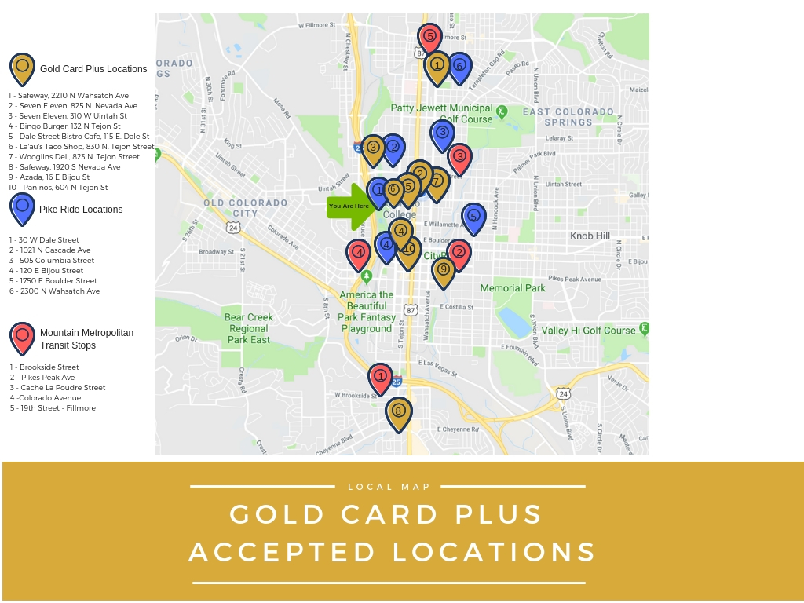

Downtown Colorado Springs Parking Garages:
If you are interested in the parking in the downtown area parking structures, please use the link below.
https://coloradosprings.gov/parking-system-enterprise

