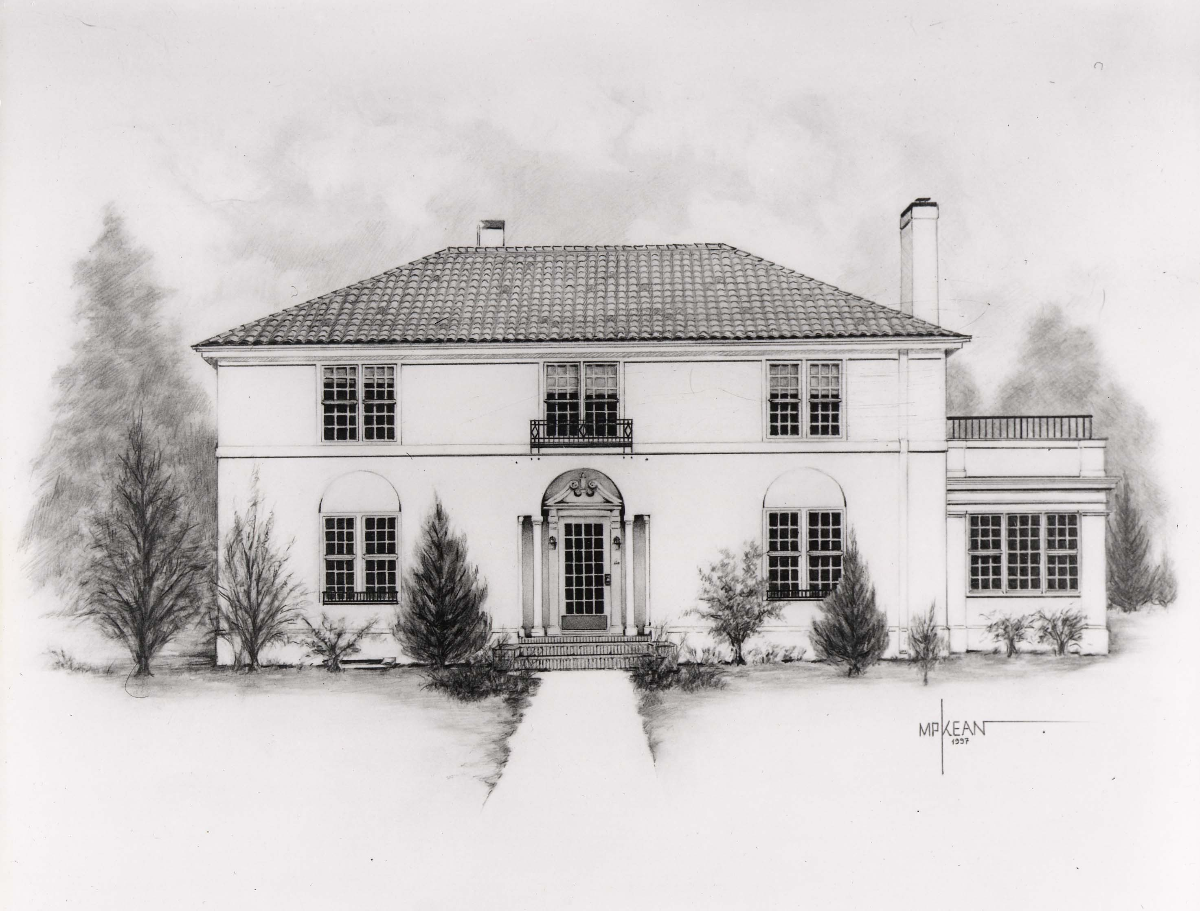

The Hulbert Center for Southwest Studies

2025-2026 JACKSON FELLOWSHIPS

**Funded by the Helen Jackson and William S. Jackson Family Endowment**

**Application deadline: Monday, March 24, 2025 (before midnight)**

The Hulbert Center for Southwest Studies invites applications for Jackson Fellowships for summer 2024 and the 2024-2025 academic year. Jackson Fellowships provide support to Colorado College faculty engaged with themes, topics, and issues **connected to the study of the US Southwest and northern Mexico**. Fellowship awards may take the form of faculty **stipends**, of support for project-related **expenses**, and/or of funding of **student** **assistants**. Faculty recipients of these awards will be designated Jackson Fellows. The Jackson Fellowship program operates independently of the College’s faculty development program, and Jackson Fellowships may be held in association with other awards and grants.

All Colorado College faculty members are eligible for Jackson Fellowships. Previous Jackson Fellows must have filed reports for previous Jackson Awards. Year-long visitors may also be eligible, but should contact the Director of the Hulbert Center concerning eligibility before they apply. The selection committee *favors* *proposals from faculty actively involved in the Southwest Studies program and proposals for projects that further program goals*. A faculty member can apply for either a Research Project Fellowship ***or*** a Course Development Fellowship (not both) during each year.

**Research Project Fellowships:**

1. Up to $5000 per year in support to a CC faculty member. Funding may be taken as a stipend (taxable), or funds may be placed in the faculty member’s research account to cover research expenses including fieldwork, conference participation, or other project needs (non-taxable). The award amount may also be split between stipend and expenses. *Major equipment purchases and work toward advanced degrees* ***will not*** *be funded.* Faculty members who take a full $5000 stipend are expected to devote the equivalent of four weeks full-time work to the project.
2. Funds to support one or two students working with CC faculty on a research project (up to $4800 per student), which should cover a student’s stipend for 8 weeks of work. Student researchers conducting less than 8 weeks of research will receive a stipend of $600 per week. *This is in accordance with standard protocol for student stipends for summer research as designated by the Office of the Dean /SCORE Program beginning in fall 2023.
3. A Fellowship recipient may receive up to $9800 total support under the two categories listed above (1 faculty fellowship and 1 8-week student stipend). If a Fellowship recipient wishes to support two students, s/he may request to use all or a portion of the faculty support designated in (1) above for additional student stipends. If soliciting two full-term student researchers, the max award will be $9600 for student research support.

**Course Development Fellowships:**

CC faculty may apply for up to $5000 for stipend and/or expenses in support of course development that is not redundant to existing Southwest Studies courses. Faculty members who take a full $5000 stipend are expected to devote the equivalent of at least four weeks' full-time work to developing the course. Course support must be in one of the following categories:

1. **New courses focusing on the Southwest**. Priority will be given to the development of courses that complement the curriculum. Some preference will be given to courses that address the new General Education curriculum adopted in 2019 and those that address components of the anti-racist curriculum initiative.

**or**

1. Major redesigns of **existing** Southwest Studies courses. (See course catalog).

**Application Procedure:**

The Director of the Hulbert Center and the Jackson Fellowship Committee evaluate applications for the Jackson Fellowship on the basis of a submitted *written proposal*. If the proposal is insufficient, the Jackson Fellowship Committee will recommend revision and resubmission of the proposal in consultation with the applicant.

The proposal must include the following materials in the following order:

**TITLE** of the project.

**STATEMENT** of whether the proposal is for a Research-Project Fellowship or a Course-Development Fellowship.

**ONE-PARAGRAPH SUMMARY** of the proposed project.

**COMPREHENSIVE DESCRIPTION** of the purpose of the Jackson Fellowship project (what you want to accomplish, the creative or scholarly importance of the task, how you will achieve your goals, and student involvement in the proposed project, if applicable). Include a section about how your work is important to the Southwest (or closely related geographic region).

**TIMETABLE** of previous work or preparation for this project, schedule during the period of Fellowship support, and anticipated further work, if any, after the end of the support period.

**METHOD OF EVALUATION** of the quality of your work and plans for other presentations or publications.

**STATEMENT** of how this project will contribute to personal long‑range scholarly growth, your field, your teaching effectiveness, and/or the improvement of the curriculum.

**STATEMENT** of the impact of your project for the Southwest Studies program and Hulbert Center activities.

**PROPOSED ITEMIZED BUDGET** and estimated date of expenditure. For student research support, please also include a budget for student stipends with explanation. *** If you are requesting a taxable income, you do not need to complete this section.

**CURRICULUM VITAE** including previous Jackson Fellowship support

**APPLICATIONS AS A SINGLE DOCUMENT IN DIGITAL FORMAT (PDF PREFERRED)**

**SHOULD BE SUBMITTED TO**

SANTIAGO GUERRA, Director of Southwest Studies

[**sguerra@coloradocollege.edu**](mailto:sguerra@coloradocollege.edu)

**Responsibilities of Jackson Fellowship Recipients:**

In addition to carrying out the work outlined in their proposals, Jackson Fellows are expected to send a report on the project and project finances to the Hulbert Center Director upon completion of the work. **This report of past Jackson support must be received before your current or any future Fellowship application will be considered.**

**Research fellowship recipients are also required to submit a copy of the publication(s) produced through Jackson Fellowship support. Recipients of course development fellowships must also submit a copy of the syllabus for the course supported through Jackson Fellowship.**

Jackson Fellows may also be asked to speak at one of the *Aficionados* luncheons.

**For more information please contact:**

**Santiago Guerra, Associate Professor and Director at** [**sguerra@coloradocollege.edu**](mailto:sguerra@coloradocollege.edu)